# Procedure Information

|  |  |  |  |  |  |
| --- | --- | --- | --- | --- | --- |
| **Line of Business / Department**  Retail Mortgage | | **Subject**  Flood Insurance Policy | | | |
| **Distribution** | **Version**  1 _PUB | | **Procedure Number**  MTG-OPS-FLOD-340 | | **Effective Date**  10/01/2011 |
| **Issued By**  **Retail/Consumer Direct** | | | **Type**  Procedure | **Level**  Standard | **Last Review**  08/03/2014 |
| **Approvals**  Jane Doe | | | | | **Next Review**  08/03/2016 |

***Printed copies are for reference only. Please refer to the electronic copy for the latest version.***

# In this document

This document contains the following topics:

Procedure Information 1

In this document 1

1. Scope 2

2. Roles and Responsibilities 2

3. Prerequisites 2

4. Applicable Policies 2

5. Applicable Systems 2

6. Process Flow 3

7. Glossary 3

8. Procedures 3

8.1. Special Flood Hazard Area (SFHA) Determination 3

8.2 Special Rules for Certain Types of Properties 7

8.3 Notice to the Borrower 8

8.4 Calculate the Amount of Flood Insurance 9

8.5 Closing 12

9. Key Performance and Key Risk Indicators (KPI & KRI) 16

10. Controls 16

11. References and Related Documents 16

12. Points of Contact 16

13. Appendix 16

14. Change Log 16

# Scope

To ensure compliance with the National Flood Insurance Act (NFIA), every loan secured by an improved property (whether site/stick-built or manufactured housing) must contain a flood certificate showing whether the property is in a Special Flood Hazard Area (SFHA).

This applies to the following:

* All lien positions (first or second)
* All occupancy types (primary, second, investment),
* All dwelling types (detached, attached, single-family, multi-family)

If the property is not in a Special Flood Hazard Area, or if the community is not mapped (and so it is not known if property is in a Special Flood Hazard Area), no other action is required.

If the property is in a SFHA:

* The Borrower must be notified prior to closing using the standard FEMA Notice to Borrower form.

**Note:** This process is currently is automated.

* Proof of flood insurance or a copy of the application for flood insurance in a satisfactory amount is required before the loan may close.

# Roles and Responsibilities

|  |  |
| --- | --- |
| **Role** | **Responsibility** |
| Borrower/Mortgagor | A Mortgagor is the Borrower in a mortgage. He or she owes the obligation secured by the mortgage. |
| Retail Processor | A Retail Processor is the primary point of contact for the client and referral sources after the loan application is complete. This teammate collects and images loan document through the Document Capture process so other teammates can view all available documents through STMPartners. This role also directs loans through the remaining stages of the origination lifecycle. Also, Processors prepare loans for Underwrting and closing, and submit them to each stage when appropriate. |

# Prerequisites

*There are no prerequisites for this procedure.*

# Applicable Policies

*There are no applicable policies for this procedure.*

# Applicable Systems

|  |  |
| --- | --- |
| **System** | **Definition** |
| No Name Mortgage Partners (STMPartners) | STMPartners is a No Name Corporate mortgage Point of Sale (POS) system used to house client and loan data. Additionally, the system is used to perform products, pricing and eligibility functions as well as interface to external (3rd party) systems. |
| CoreLogic | CoreLogic is the name of the vendor that provides No Name Mortgage with flood certifications for mortgage loans. |
| Mortgage Loan Control System (MLCS) | System of record and loan origination system used by No Name Mortgage to collect application data used in the loan origination. |

# Process Flow

Click here to view the [procedure number, procedure name, and process title] process flow.

# Glossary

|  |  |
| --- | --- |
| **Term** | **Definition** |
| FEMA | Federal Emergency Management Agency |
| FHA | Federal Housing Administration |
| Flood Cert | Document showing the flood zone classification of the subject property. |
| Life of Loan (LOL) Flood Cert | Flood certification that includes an agreement to track the property flood zone status over the life of the loan. |
| NFIP | National Flood Insurance Program |
| Special Flood Hazard Area (SFHA) | Land in the flood plain within a community subject to a 1% or greater chance of flooding in any given year. Flood Zone classifications beginning with the letters **“A” or “V”** are Special Flood Hazard Areas. |

# Procedures

## Special Flood Hazard Area (SFHA) Determination

**NOTE**: If the property is not in a Special Flood Hazard Area, or if the community is not mapped (and so it is not known if property is in a Special Flood Hazard Area), no other action is required.

Retail

Each file must have a Life of Loan (LOL) flood cert showing the flood hazard status of the property and the community flood insurance program participation status.

The flood certificate must be retained in the loan file and is currently imaged automatically.

#### Step 1 – Ordering Flood Certificate

The flood certificate is ordered automatically through CoreLogic Flood Services, after the initial Submit to No Name Mortgage, Inc. or Submit for Disclosure action.

1. Open STMPartners
2. Open the **Services** tab. To access the section, the user would either:
   1. Select the **View Services Request/Status** option under the **App** menu.
   2. Or, If the user is in the application, select the **Services** option in the menu on the left-hand side of the page.
3. Flood order information will be displayed in **Flood Certificate** section (Figure 1). When the order is complete, the flood determination page will automatically populate with the flood certification information. STMPartners will display real-time status updates of the request in this section, as well.

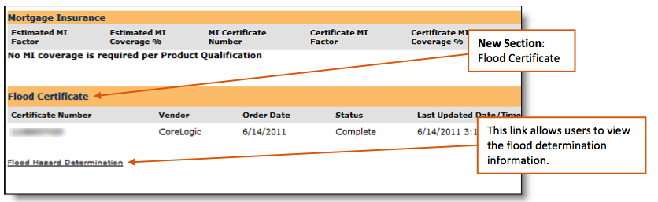

Figure 1

EXCEPTION: If an issue occurs, such as an auto order action has failed or it produced an error, the flood cert can be *manually ordered* (Figure 2).

1. Open STMPartners.
2. Navigate to **Flood Certificate** section on the **Services** tab.
3. Select **Order Flood Certificate** link.
4. Select *Life of Loan Determination* as the **Flood Product Type**.
5. Click **Order Certificate**.

#### Macintosh HD:Users:gsujess:Documents:SunTrust Procedures:Flood Policy Screenshots:5.pdf

Figure 2

#### Step 2 – Status Options

To view the status of an order, access the **Flood Certificate** section under the **Services** tab (Figure 1).

For more information about the different statuses, please reference Figure 3 below.

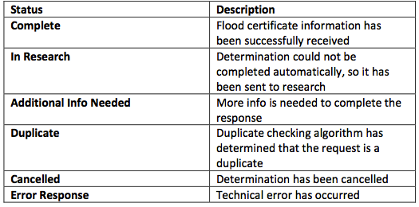

Figure 3

#### Step 3 – View/Update Options

**NOTE**: This information will automatically flow over to the MLCS (Screen Z74) when a submit action occurs.

**NOTE**: Access to the Update Flood Request link is permission-based.

1. When the flood certificate order is complete, the system will automatically populate the

**Flood Hazard Determination** page. The data on this page was extracted from the flood certificate. Click the link located in the **Flood Certificate** section to access the webpage (Figure 4).

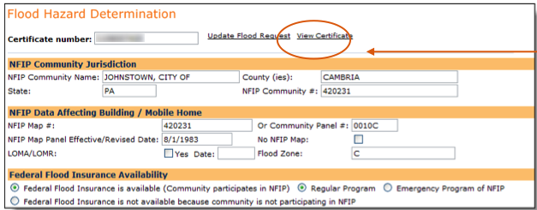

Figure 4

2. If necessary, the **Update Flood Request** link allows the user to perform addition

actions (cancellation, change, reissue, or dispute) to the flood request order.

* Select the appropriate action, add comments, and click **Submit Request**  (Figure 5)

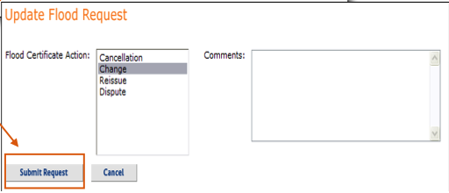

Figure 5

#### Step 4 – Filing the Flood Cert

***If Property is not in a SHFA***

A copy of the flood determination must be retained in the loan file and is currently imaged automatically.

No flood insurance or further actions are required.

***If Property is in a SHFA***

* Check community status:
* Non-participating or suspended:
* Application must be denied or file declined for purchase according to established LOB procedures.
* The reason for denial on the Adverse Action Notice would be: “Flood Insurance not available due to community status.”
* The Borrower must still receive the standard FEMA Notice to Borrower. **Note:** This process is currently handled by a third- party vendor.
* Regular, emergency or probationary status:
* A Notice to Borrower form and proof of flood insurance are required (continue to Step 8.2).
* FHA Does Not Allow Private Insurance:
* FHA requires eligibility for the National Flood Insurance Program (NFIP) on all residential buildings and related improvements located within a Special Flood Hazard Area (SFHA). They do not allow private flood insurance.

## Special Rules for Certain Types of Properties

If the property is one of the following types of property, continue in this step.

* A condo
* A construction/perm loan
* Only partially in a SFHA
* In a Coastal Barrier Resources System (CBRS) area or Otherwise Protected Areas (OPAs)

If the property does not fall under these guidelines, skip to Step 8.3.

***Condo***

The condominium owners association must maintain flood insurance building coverage on the specific building in which the unit is located for the lesser of:

* 100% of the building’s replacement cost, or
* $250,000 multiplied by the number of residential units in the building.

If there is no or insufficient Association coverage the borrowers must purchase their own FEMA policy.

**Note:** For FHA loans only, the Homeowners Association (HOA), not the borrower or individual unit owner, is responsible for obtaining and maintaining adequate flood insurance under the NFIP on buildings located in a SFHA. The flood insurance coverage must protect the interest of borrowers who hold title to an individual unit as well as the common areas of the condominium project.

1. Obtain a copy of the Association’s policy covering the building in which the subject property is located.
2. Input the number of units in the building.
3. The calculator will divide the amount of coverage by the number of units.
4. The calculator will determine the amount of coverage for the subject property. To be acceptable, it must be at least as large as the required amount of insurance.

***Partially in a SFHA***

* If the improvements are NOT IN a SFHA, flood insurance IS NOT required.
* If principal structure is NOT IN a SHFA, but an outbuilding, which is not serving as security for the loan IS IN, flood insurance IS NOT required.
* If any part of the principal structure IS IN a SFHA, flood insurance IS required.

***CBRS/OPAs***

Boundaries of Coastal Barrier Resources System (CBRS) areas and Otherwise Protected Areas (OPAs) are established and mapped by the U.S. Department of Interior’s Fish and Wildlife Service, which are identified by the Department of the Interior’s legislation.

* FEMA flood insurance is available under some circumstances. If it is available, it must be purchased under the same guidelines as any property in an SFHA.
* If a FEMA policy is not available, a private policy is required.
* If no FEMA or private policy is available, or none will be purchased, the subject property is not eligible for financing by No Name. No Name must issue an adverse action notice denying the application, the reason “other” and language such as “property in SFHA without flood insurance is not eligible for financing by No Name Mortgage, Inc.”
  + Lenders can determine whether a property is located in a CBRS area or OPA by logging onto the CBRS page of the FEMA website: <http://www.fema.gov/business/nfip/cbrs/cbrs.shtm>.
  + Assistance may also be available from insurance agents and companies and from community officials.
  + FHA Coastal Barrier Resource System - FHA will not insure or originate any loan on property (existing or proposed) located within a designated Coastal Barrier Resource System (CBRS), regardless of whether flood insurance is available.

## Notice to the Borrower

Retail/Consumer Direct/Wholesale

Send the *Notice of Special Flood Hazards and Availability of Federal Disaster Relief Assistance* to applicants. It is included with the flood certification as the second page.

* Once the Notice has been sent to the applicants, keep a copy of it in the file with a mailed/delivered date.
* Must be sent as soon as possible after receipt of flood certification.
* A signed copy of the Notice must be in the file. If the applicants have not signed and returned the initial Notice prior to closing, a new copy must be included with loan documents and signed at closing

## Calculate the Amount of Flood Insurance

The flood insurance calculator is accessed in STMPartners on **Flood Hazard Determination** page.  Viewing and using the flood calculator is permission-based and will only occur under the following circumstances:

**NOTE:** All three circumstances must be present in order for the flood calculator to appear.

* Subject property has been identified to be in a SFHA.
* Flood Zone field contains an “A” or “V.”
* Determination indicator must be “Yes.”

#### Step 1 – Viewing the Calculator

The link for the flood insurance calculator is located to the right of the Flood Certificate number (Figure 6).

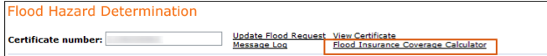

Figure 6

#### Step 2 – Using the Calculator

1. To use the calculator, users must complete the required fields and then click **Calculate**.

There are three types:

* Single Family property type
* Condo property type
* Non-Cost Approach and Cost Approach (Figure 9)

Single Family Property Type

**NOTE:** If there is a discrepancy in the times, user will receive a message below the dates.

1. User completes the bold fields and clicks **Calculate** (Figure 7).
2. STMPartners will populate flood insurance information and shortfall in the **Calculated Fields** section.
3. STMPartners records the last time of the last calculation and last save of application data.

Macintosh HD:Users:gsujess:Documents:SunTrust Procedures:Flood Policy Screenshots:7.pdf

Figure 7

Condo Property Type

1. User completes the bold fields and clicks **Calculate** (Figure 8).
2. STMPartners will populate flood insurance information and shortfall in the **Calculated Fields** section.
3. STMPartners records the last time of the last calculation and last save of application data.
4. In the example below, the calculator has been completed. Notice the message the system sends regarding the time stamps.

Macintosh HD:Users:gsujess:Documents:SunTrust Procedures:Flood Policy Screenshots:8.pdf

Figure 8

Non Cost Approach and Cost Approach

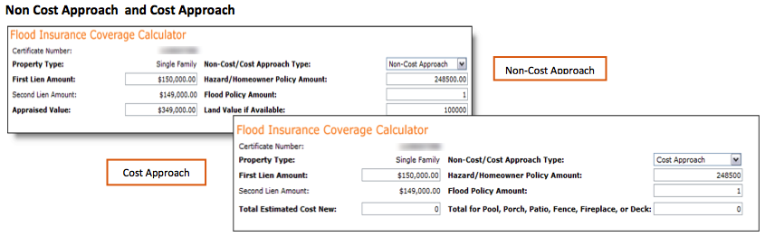

Figure 9

2. Access the PDF copy of the flood insurance calculator outputs under **Access Documents**.

* Retail Operations teammates (MPPT-enabled)

1. Access and print the flood calculator results.
2. Upload the flood calculator through **Capture View** to submit to branch.

3. The flood insurance calculator will determine if there is a shortfall in the flood insurance

coverage. The loan will not pass the final data check in STMPartners if a shortfall exists or if the flood insurance calculator was not run on a loan requiring flood insurance.

Escrows

Mortgage requires an escrow for flood insurance, if we are establishing

escrows on the loan, in part or full, for any taxes, hazard insurance, mortgage

insurance or other reasons. We do not require flood insurance escrow if we do not establish other escrows on the loan. As a reminder, mortgage insurance escrow cannot be waived.

Borrower Disputes

Loan secured by property in a SFHA cannot close or be purchased without FEMA flood

insurance in the required amount (with the Construction/Perm loan exception). Additionally, the flood zone on the policy must match the flood zone on the determination.

A Borrower disputing the flood determination has 2 options:

* Obtain flood coverage and cancel post-closing, if it is ultimately determined flood insurance is not required, OR
* Wait to close until dispute has been resolved.

***Retail***

* Flood insurance is required to close the loan.
* The Borrower may dispute the finding with FEMA after closing.

# Key Performance and Key Risk Indicators (KPI & KRI)

*There are no KPIs or KRIs associated with this procedure.*

# Controls

Click here to view the controls matrix.

# References and Related Documents

Bulletins are available for the following years:

* [2011](http://retaillendingguide.noname.com/doclib/resource_center/Ghost_Docs/Related_bulletins/2011/RFloodIns2011.pdf)
* [2010](http://retaillendingguide.noname.com/doclib/resource_center/Ghost_Docs/Related_bulletins/2010/RFloodIns2010.pdf)
* [2009](http://retaillendingguide.noname.com/doclib/resource_center/Ghost_Docs/Related_bulletins/2009/RFloodIns2009.pdf)

# Points of Contact

Contact Operational Risk Compliance, or your line of business compliance source, for additional information.

For condominiums, coverage questions may be emailed to [mortgage.condodesk@nomail.com](mailto:mortgage.condodesk@nomail.com).

# Appendix

*There are no appendices for this procedure.*

# Change Log

|  |  |  |  |  |
| --- | --- | --- | --- | --- |
| **Version** | **Section** | **Change Author** | **Date** | **Change Summary** |
| 1_PUB | ALL | Jane Doe | 8/3/2012 | Update to reflect current activity. |